## 



KloudCount: Cycle Counting

**Cost-benefit Analysis Report**

11.03.2024

**─**

Group 10

| Team Member Name: | Assigned Task |
| --- | --- |
| Abarron Wong | Task 1 |
| Abarron Wong | Task 2 |
| Spencer Legaspi | Task 3 |
| Madi Leong | Task 4 |
| Anwar Ayyad | Task 5 |

# Task 1

## 5 Tangible Benefits of having an app to manage inventory better

1. Increase in Revenue - With an overhaul of the current system, an app would eliminate discrepancy in manual inventory checking and thus generate more revenue by having a more reliable system.
2. Reduced Operational Cost - An app would eliminate the demand for manual labor leading to less human error and need for employee labor thus giving them more time to focus on customer service.
3. Enhanced Customer Service - With an app to manage current inventory, employees can provide an accurate service for customers looking to shop for a particular item.
4. Improvement in Supply Management - Having an app allows the reordering process to be more seamless by using store data to know when to request product shipments.
5. Increase in Financial Future - With present data and analytics that come from the app, this allows the business to see what they need in inventory, leading to more precise budgeting and financial planning.

## 5 Intangible Benefits of having an app to manage inventory better

1. Improved Employee Positioning - by having a system running inventory, employees can focus more on helping customers rather than sitting in the back.
2. Increased Customer Satisfaction - With an app, customers can be provided with accurate feedback on item statuses and make more informed purchases.
3. Enhanced Reputation - With consistent meets of demands from customers and lessening the stockout/overstock situation, this improves our reputation for reliability. Over time, this can strengthen the trust and brand image.
4. Improved Supplier Relationships - With more accurate, present inventory data, the business can communicate with greater ease on what they have and need. Over time, this can lead to stronger partnerships, treatment, and pricing.
5. Scalability and Innovation - Having a scalable, app-based inventory management system can handle more volume lessening the disruptions. Implementing an app reveals the business’s pursuit of technology for improvement, and a smooth expansion.

# Task 2

## 5 Tangible Costs of having an app to manage inventory better

1. Developing the app - Variety of fees for developers, designers, and project managers who are responsible for creating the app. Costs can vary if done in-house or outside.
2. Licensing and Platform - Purchasing/subscribing to the software dev tools, platforms, or any base for which the software is made. Additionally, the costs to register the app to Apple’s App Store or Google Play, which commonly see fees.
3. Hardware and Infrastructure - The app will likely rely on cloud storage and server hosting for data processing and storage. The actual database system to handle data will incur costs. A Network connection to host the app, as well as data security.
4. Compliance and Legal Fee - Research suggests that an app like this means data protection and privacy regulations (GDPR), may incur fees. Licensing the app or any patents that may have been brought up may also rouse fees.
5. Maintenance and Update Fee - Expenses for timely updates, bug fixes, and technical support to help the app function over time. As technology grows, there may need evolutions of the app or integrations with newer systems.

## 5 Intangible Costs of having an app to manage inventory better

1. Employee Resistance to Change - Not all employees will adapt to having an app kindly or adaptively, especially if they are comfortable with the current way of things. This resistance may slow down productivity, especially during the transition.
2. Security and Risk - Having a new online system introduces risk to management of data, especially with employees who are clueless about protocol. This may lead to data mishandling, risks in data privacy, compliance, and data breaches.
3. Workload for IT and Support Teams - They may experience heavier workloads due to having to train employees, troubleshooting early issues, and constant support. This decreases time and resources for other IT projects and support functions.
4. Opportunity Cost - Placing lots of time, money, and resources into this app means less time, money, and resources for other projects and ideas. If the app does not work after launch then the resources would have been wasted.
5. Learning Curve and Dependence - In the eyes of many employees, a new app means time needed to learn it. This may cause frustration or anxiety, especially those with less experience in technology. On the other hand, if this app is used too much, then if there are technical issues, outages, or updates that occur, this will hinder operations.

**Task 3**

## 3 One-Time Costs

1. Hardware and Equipment
2. Software Purchase
3. Employee training

## 3 Recurring Costs

1. Licensing and Platform
2. Compliance and Legal Fee
3. Inventory Adjustments

|  | Weight | Your Project | | Alternative B | | Alternative C | |
| --- | --- | --- | --- | --- | --- | --- | --- |
| Rating | Score | Rating | Score | Rating | Score |
| One-time costs | | | | | | | |
| Hardware Cost | 18 | 5 | 90 | 5 | 90 | 5 | 90 |
| Software Cost | 20 | 5 | 100 | 3 | 60 | 4 | 80 |
| Training | 12 | 2 | 24 | 1 | 12 | 1 | 12 |
| Recurring costs | | | | | | | |
| Licensing and Platform | 22 | 5 | 110 | 5 | 110 | 5 | 110 |
| Compliance and Legal Fee | 15 | 2 | 30 | 4 | 60 | 3 | 45 |
| Inventory Adjustments | 13 | 1 | 13 | 2 | 26 | 1 | 13 |
| Total | 100 |  | 367 |  | 358 |  | 350 |

## Narrative of Analysis

1. This is a Cost Matrix that is made to compare 3 different project solutions based on cost factors. The cost matrix would help us decide which alternative works best by using one-time and recurring costs, as well as assigning a weight and rating to each category. The cost matrix is important because it is used to evaluate and compare different projects based on their various costs and importance (weight) to the project. To sum it all up, our project has a total score of 367 points which is the highest ranking out of the 3. Project B has a total of 358 points and Project C with a total of 350 points.

**Task 4**

## Cost-Benefit Analysis Calculations

| **Project Information** |  |
| --- | --- |
| **Project Lifespan** | 5 years |
| **Discount Rate** | 0.04 |
| **Benefits** |  |
| Year 0 | $ - |
| Year 1 | $ 3,700.00 |
| Year 2 | $ 5,500.00 |
| Year 3 | $ 4,000.00 |
| Year 4 | $ 4,200.00 |
| Year 5 | $ 6,500.00 |
| **Costs** |  |
| Fixed Cost | $ 6,000.00 |
| One-Time Cost Y1 | $ 1,300.00 |
| One-Time Cost Y2 | $ 1,700.00 |
| One-Time Cost Y3 | $ 2,500.00 |
| One-Time Cost Y4 | $ 2,500.00 |
| One-Time Cost Y5 | $ 2,500.00 |

| **Year** | 0 | 1 | 2 | 3 | 4 | 5 | **TOTAL** |
| --- | --- | --- | --- | --- | --- | --- | --- |
| Discount Rate: 0.04 | 1.00 | 0.96 | 0.92 | 0.89 | 0.85 | 0.82 |  |
| Net Economic Benefit | $ - | $ 3,700.00 | $ 5,500.00 | $ 4,000.00 | $ 4,200.00 | $ 6,500.00 |  |
| PV of Benefits | $ - | $ 3,557.69 | $ 5,085.06 | $ 3,555.99 | $ 3,590.18 | $ 5,342.53 |  |
| **NPV of all Benefits** | $ - | $ 3,557.69 | $ 8,642.75 | $ 12,198.74 | $ 15,788.91 | $ 21,131.44 | **$ 21,131.44** |
|  |  |  |  |  |  |  |  |
| One-Time Costs | $ 6,000.00 | $ - | $ - | $ - | $ - | $ - |  |
| Recurring Costs | $ - | $ 1,300.00 | $ 1,700.00 | $ 2,500.00 | $ 2,500.00 | $ 2,500.00 |  |
| Discount Rate: 0.04 | 1.00 | 0.96 | 0.92 | 0.89 | 0.85 | 0.82 |  |
| PV of Reccuring Costs | $ - | $ 1,250.00 | $ 1,571.75 | $ 2,222.49 | $ 2,137.01 | $ 2,054.82 |  |
| **NPV of all Costs** | $ 6,000.00 | $ 7,250.00 | $ 8,821.75 | $ 11,044.24 | $ 13,181.25 | $ 15,236.06 | **$ 15,236.06** |
|  |  |  |  |  |  |  |  |
|  |  |  |  |  |  |  |  |
| **Overall NPV** |  |  |  |  |  |  | $ 5,895.38 |
| **ROI** |  |  |  |  |  |  | 0.3869356111 |

| **Break Even Analysis** |  |  |  |  |  |  |
| --- | --- | --- | --- | --- | --- | --- |
| Yearly NPV Cash Flow | $ (6,000.00) | $ 2,307.69 | $ 3,513.31 | $ 1,333.49 | $ 1,453.17 | $ 3,287.71 |
| Overall NPV Cash Flow | $ (6,000.00) | $ (3,692.31) | $ (178.99) | $ 1,154.50 | $ 2,607.67 | $ 5,895.38 |
|  |  |  |  |  |  |  |
| Break Even Point Fraction |  |  |  |  |  | 0.1342293333 |
| **Break Even Point** |  |  |  |  |  | 2.13 |

## Interpret Results

1. The cost analysis of the KloudCount project shows a positive Overall NPV of 5,895.38, which means that the system not only pays for itself but also adds value to Kloud K-Pop over the five-year project lifespan, With an ROI of 38.69%, the investment in KloudCount is expected to yield a healthy return, indicating the the benefits, such as improved inventory accuracy and reduced time spent on manual checks, outweigh the initial and ongoing costs of the new system. This aligns with our goal of streamlining inventory management to minimize stock discrepancies which can enhance customer satisfaction and operational efficiency.

## Break Even Point Plot and Profitability

| **Year** | 0 | 1 | 2 | 3 | 4 | 5 |
| --- | --- | --- | --- | --- | --- | --- |
| NPV of all Benefits | $ - | $ 3,557.69 | $ 8,642.75 | $ 12,198.74 | $ 15,788.91 | $ 21,131.44 |
| NPV of all Costs | $ 6,000.00 | $ 7,250.00 | $ 8,821.75 | $ 11,044.24 | $ 13,181.25 | $ 15,236.06 |

1. KloudCount reaches its break-even point at around 3.34 years. This means that a little over three years into the project, Kloud K-Pop will start seeing a positive return on their investment in the new system. After this point, the system will contribute to Kloud K-Pop’s profits, providing both financial benefits and operational improvements that make inventory management more simple and reliable. 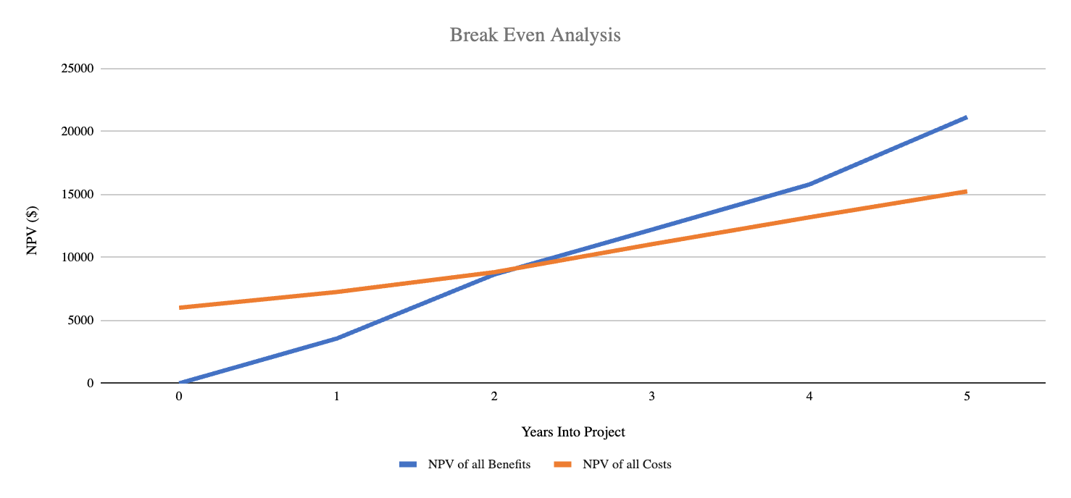

**Task 5**

## Cost-Benefit Analysis Calculations

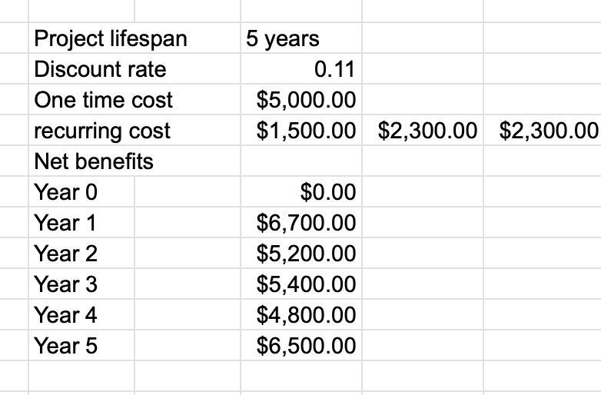

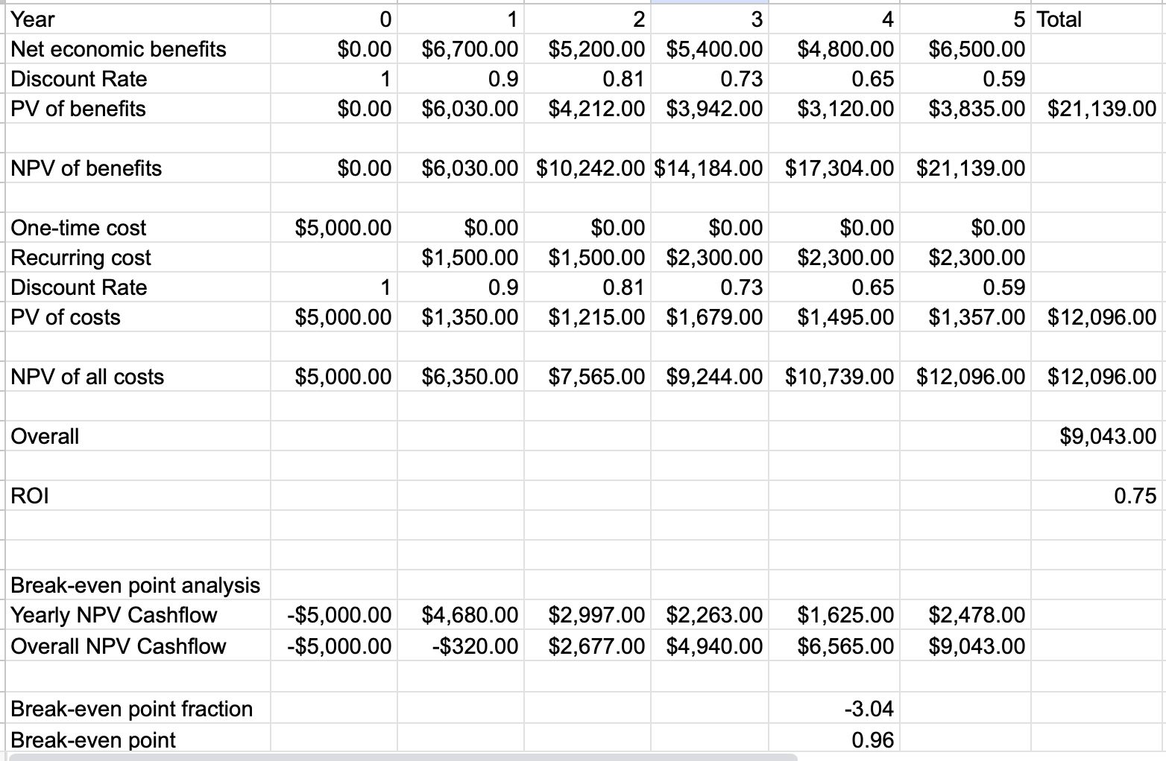

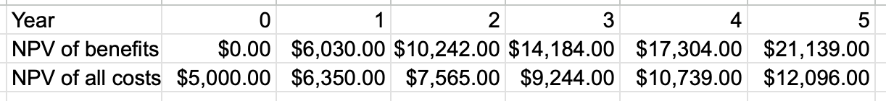

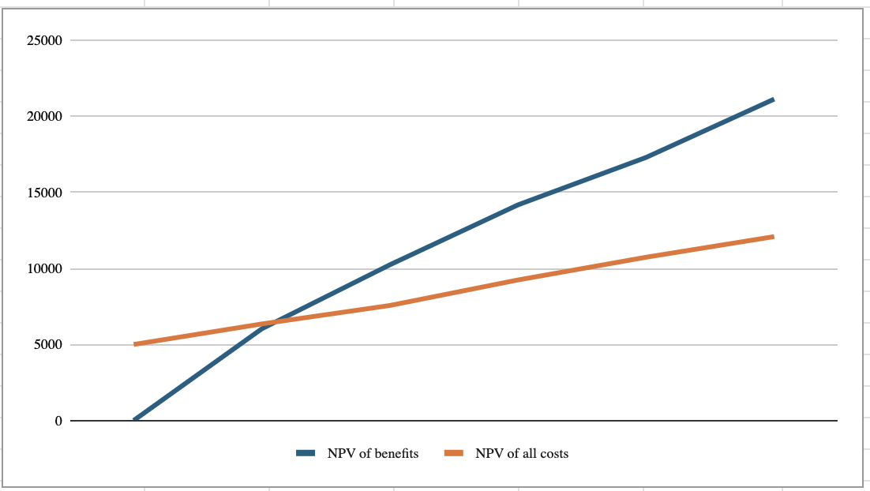

## Interpret Results

The cost evaluation for the KloudCount project yields a positive total net present value of $9,043.00, demonstrating that the program not just compensates by itself but also adds value to Kloud K-Pop throughout the five-year project duration. With a 75% ROI, the KloudCount investment is expected to create large profits, meaning that the benefits of enhanced stock consistency and shorter manual inspection times surpass the new system's initial and ongoing costs. This aligns with our goal of improving inventory management to eliminate stock variances, which can improve customer happiness and compliance.

## 

## Break Even Point Plot and Profitability

1. KloudCount reaches its break-even point after approximately 2.15 years. This means that, approximately three years into the project, Kloud K-Pop will begin to see an increase in return on their investment in the new system. Following this phase, the platform will help boost Kloud K-Pop's earnings by giving financial benefits as well as operational enhancements that will render inventory management easier and more reliable. This graph represents the overall npv I estimated because it shows that the difference between the npv of costs and npv of benefits is around $9,043.00.