# Rock Solid Industrial Parts, Inc

Strategic Digital Transformation for Revenue Growth

Date Submitted: 03/29/2025

Report Expressly for: Janice Drake

**Executive Summary**

Rock Solid Industrial Parts (RSIP) is going forward with a three-year strategic expansion plan involving the West Coast and Mountain States to increase the revenue from $33 million to $72 million. With this aggressive approach, RSIP will look to perform digital transformation to drastically improve in the sales operations, warehouse operations, finance and accounting departments, human resources, and IT department. RSIP operates with outdated systems across all departments. To keep up with the workload during the expansion, the organization must incorporate efficient and scalable digital solutions. Any technological changes will be aligned with business milestones to ensure all goals are met. The proposed budget is 250K to 750K, which allows flexibility while making sure critical systems are prioritized. Minimizing disruption is important during this process and doing so will allow employees to continue working smoothly throughout the upgrade. This transformation is looking to improve efficiency and decision-making, which will steer RSIP to profitable revenue growth and help the company gain a competitive advantage in the industrial distribution market securing long-term success.

Written By:

Quach, Casey

casey.quach@sjsu.edu

Table of Contents

Rock Solid Industrial Parts, Inc 1

Introduction 5

Business Functions Affected by Digital Transformation 5

Field Sales 6

Situation 6

Analysis 6

Solution 7

Benefit 8

Inventory Management 9

Situation 9

Analysis 9

Solution 10

Benefit 11

Finance & Accounting 11

Situation 11

Analysis 12

Solution 12

Benefit 13

Human Resources (HR) 13

Situation 13

Analysis 13

Solution 13

Benefit 14

Information Technology (IT) 14

Situation 14

Analysis 15

Solution 15

Benefit 16

Executives 17

Situation 17

Analysis 17

Solution 17

Benefit 17

Technology 18

Software 18

Hardware 21

Data 22

Infrastructure 22

People 24

Structure 24

Most Difficult Technical Task 24

Analysis 24

Solution 24

Risks & Mitigation 25

Risk 1 – Employees Resistance to Change 25

Since RSIP’s employees have worked there for a prolonged period, each person has most likely developed a routine to do their everyday work. They are used to their ways, which makes it seem like their current processes have no problems. Introducing new technological systems will make working more efficient, but it won’t seem like it to everyone in the company. It would serve more as a disruption, which leads to conflict and resistance to change. 25

Risk 2 – Lack of Experience 25

Being the lone IT person, there may be problems when coming across technological issues. As digital transformation is being implemented, there will be demand for IT support in all departments. The lack of technical knowledge will also contribute to the challenges because it can lead to inefficient troubleshooting and dependencies on outside technical support. 25

Risk 3 – Security Concerns 25

RSIP lacked technology in all aspects and that creates security concerns when trying to enforce digital transformation. During the transition, RSIP is prone to attacks and unauthorized access from hackers because without a cybersecurity infrastructure in place before the transition, everything here is brand new. Data will not be protected 100% and any loss of this information will result in financial loss and damage to the company’s reputation. 25

Timeline 26

Budget 27

Conclusion 27

Appendix 28

Infrastructure Diagram 28

HQ and Warehouse 28

Remote Offices 28

Salespeople on the Road 29

Endnotes 30

General 30

Budget 31

# Introduction

Rock Solid Industrial Parts (RSIP) is in preparation for an expansion bringing operations into Southern California and the Mountain States with plans to expand into San Diego in Year 2 then Denver in Year 3. This growth will bring out new challenges with increased sales to maintaining efficiency within the company. RSIP has a strong foundation, but the use of outdated systems and manual tasks poses as a risk to the growth of the organization.

Digital Transformation must be done to improve data management, communication, and increase efficiency. The approach will focus on integrating technology into important functions across different departments. Not all areas of the company need technological change, and a thorough evaluation will help determine the upgrades that are the most beneficial. Being able to do so will ensure the company’s success in handling the increased workload with minimal interruptions.

# Business Functions Affected by Digital Transformation

As RSIP prepares for their three-year strategic expansion plan, the organization must focus on its main business functions to be ready for the increase in sales, growth, and operations. Digital transformation will drastically improve operations across different departments, allowing them to keep up with trends. With there being multiple locations, streamlining operations and enhancing processes can assist with the overall collaboration between all.

|  |  |  |  |  |  |
| --- | --- | --- | --- | --- | --- |
| Digital Transformation Focus | | Digital Transformation Type | | | |
| Function | Notes | U | A | I | R |
| Field Sales | CRM system for automation and remote access with AI integration. |  |  | X |  |
| Inventory Management | Cloud-Based system for real-time tracking. |  |  | X |  |
| Finance & Accounting | Upgrade the current system while not changing too much. | X |  |  |  |
| HR | Digital HR software for payroll and hiring. |  | X |  |  |
| IT | Enhance IT infrastructure and systems. |  |  | X |  |
| Executives | Data-Analytics tools to help decision-making and research. |  | X |  |  |

The table above gives an outline to important business functions that will be affected by digital transformation. Upgrades, automation, and information will be implemented where necessary, while minimizing as much disruption as possible. The following sections give a breakdown of how digital transformation impacts the functions listed above, focusing on improvements, benefits, and explanations on how it aligns with RSIP’s expansion plan.

## Field Sales

### Situation

RSIP’s field sales team strongly contributes to profitable revenue growth by maintaining customer relationships and assisting with sales during the expansion. Field salespeople are constantly on the move, often traveling from site to site and working remotely. They are occasionally on-site, but that is primarily for sales meetings and training sessions.

Currently, RSIP’s field sales team is relying on outdated process such as spreadsheets, manual sales tracking, and in-person only meetings. This leads to many inefficiencies, which can hinder the customer’s experience and slow processes down. As the organization looks to expand into San Diego and Denver, these challenges will become more difficult to deal with, requiring a digital solution to support the sales operations.

### Analysis

|  |  |
| --- | --- |
| Data/Information Use Case | |
| Function Name: Field Sales | |
| Process Name | Notes/Comments |
| Lead Tracking & Reporting | Manually done using Excel sheets and email threads. This leads to bad visibility and inefficiencies in the process. |
| Customer Data Tracking & Management | Customer information is stored across many platforms making it hard to track. |
| Order Processing & Quote Generation | The sales team documents orders and quotes manually to enter into the system later. This process is prone to errors, delays, and miscommunications. |
| Route & Territory Planning | Sales representatives frequently travel by car, rail, and plane. Planning routes individually wastes time, which means less customers. |

The current field sales processes are made up of manual tools and inefficient systems, which doesn’t maximize the full potential of the department. These limitations will be exposed during the expansion, so the need for digital solutions that are also mobile-friendly are necessary to automate certain processes, assist with collaboration, and always guarantee reliable access.

### Solution

|  |  |  |
| --- | --- | --- |
| Requirement Specification | | |
| Technology Name | Customer Relationship Management (CRM) | |
| Requirement Name | ID# | Description/Definition |
| Track & Manage Customer Data | C-001 | Integrated storage for customer interactions, information, history, and preferences. |
| Track & Report Sales | C-002 | Real-time access across teams and territories to capture, organize, and report sales data. |
| Process Orders | C-003 | Create and submit orders directly from the field with little manual input. |
| Generate Quotes | C-004 | Automation tool or feature to generate accurate quotes on-site and remotely. |
| Mobile Access | C-005 | Mobile application that field sales representatives can access on the go to access and update information. |
| Sync with Inventory Management System | C-006 | Allows sales representatives to check availabilities in real-time. |
| Route Optimization | C-007 | Provides daily travel schedules and territory planning. |
| AI Sales Insights | C-008 | Uses AI to analyze sales data, give suggestions, and forecast to sales representatives to assist in decision-making. |

A CRM system needs many capabilities to support RSIP’s field sales team. These features are expected to improve efficiency, customer service, and allow the team to access information in real-time. As RSIP carries out their expansion plan, workers should have a centralized, mobile-ready CRM system that can automate certain tasks and make smarter decisions with the data being easily accessible. This is required to manage a growing sales force and is also necessary to contributing to the company’s profitable revenue growth.

### Benefit

Implementing a Customer Relationship Management (CRM) system offers many benefits ranging from increasing sales performance to impacting customer engagement. Industry research shows that there is an overall positive percentage increase in all aspects of sales when using a CRM system.

Figure 1: CRM Benefits

Currently, RSIP’s field sales team relies on manual processes (spreadsheets, emails) to manage customer data. A CRM system will be able to address the visible flaws by automating sales workflows, keeping all customer information in one place, and allowing sales representatives to access all this information anywhere they are. With RSIP planning to expand over multiple territories, it is important for people in the field sales team to have the ability to access and update their sales data no matter where they are. As shown in Figure 1, mobile CRMs can improve team productivity by 50%, which leads to the increase of profitable revenue growth. These statistics show the value of a CRM system and how much of a positive impact it has to an organization.

While a CRM system will improve sales and customer related operations, RSIP must also address the problems that directly impact warehouse operations. Inventory management is crucial because as the company expands, there will be more inventory to track. In today’s world, having an efficient and modern inventory solution is key, especially in warehouse operations. Not being able to do so can result in inefficiencies and difficulties in keeping up with competitors.

## Inventory Management

### Situation

As RSIP goes through with their strategic expansion plan, they will be entering new markets and creating more product lines. Having a real-time inventory management system where all the information is in one place will be vital to the success of the company. Even though the inventory directly impacts warehouse operations, it also affects sales, finance, and the overall organization.

Presently, RSIP uses manual processes like paper-based tracking and spreadsheets to manage their inventory. This system is ineffective because it can cause inaccuracies, which would lead to delays within the department. The company is growing, so as the volume of orders increases, these problems will start to occur more often. These concerns pose a risk to RSIP and can interfere with meeting customer expectations. Implementing a modern inventory management solution is essential to addressing the current problems for the company.

### Analysis

|  |  |
| --- | --- |
| Data/Information Use Case | |
| Function Name: Inventory Management | |
| Process Name | Notes/Comments |
| Stock Tracking & Updates | Done manually on spreadsheets. Prone to inaccurate data and user errors. |
| Order Fulfillment | Inventory is updated manually when there is an order. This causes delays and can cause inaccuracies if inputted too fast. |
| Inventory Reporting | Excel files are used to keep track of reports. This is hard to keep track, and inventory is portrayed in real-time. |
| Warehouse Operations Communication | Emails and phone calls are the main source of communicating updates for Warehouse Operations. There is an increased risk of miscommunication with this process. |
| Inventory Tracking Across Multiple Locations | RSIP’s expansion will affect how inventory is tracked between locations. |

The current inventory management system heavily relies on manual processes, which leads to frequent delays and accuracy concerns. RSIP is expanding, so not having a centralized system to monitor inventory will end up causing many problems soon that may become disastrous. Communication is also important since warehouses at different locations should be able to communicate with each other. To support this growth, a digital inventory management system is needed to have all processes under one area.

### Solution

|  |  |  |
| --- | --- | --- |
| Requirement Specification | | |
| Technology Name | Inventory Management System (IMS) | |
| Requirement Name | ID# | Description/Definition |
| Tracking Stock Levels | I-001 | Accurate real-time tracking of inventory. |
| Automate Stock Updates | I-002 | Automatic updates as orders are processed. |
| Centralized Inventory | I-003 | Stock is visible across all warehouse locations. |
| System Integration Across Other Departments | I-004 | Synchronizes information with systems in different departments (CRM & Accounting). |
| Access Controls | I-005 | Workers are given roles to control who can edit or view the data. |
| Barcode Scanning | I-006 | Allows warehouse workers to track goods when receiving, storing, and shipping. |

RSIP’s current inventory processes are inefficient, so having a cloud-based Inventory Management System will vastly improve operations. Being able to streamline tasks and collaborate across departments efficiently will help maintain service standards as operations continue to grow.

### Benefit

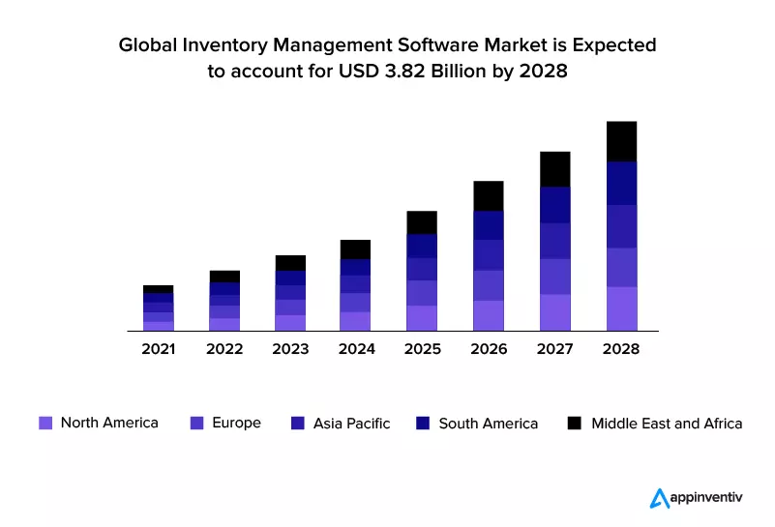Cloud-based Inventory Management Systems (IMS) offer many advantages that contribute to the company’s growth goals. The current system is prone to human error and lacks consistency in reporting. An IMS system addresses those problems and reduces the overall labor that gets put into a process.

Figure 2: IMS Market Expectation

In today’s world, maintaining a competitive edge against other companies is important to long-term success. Companies around the world are using IMS systems to enhance business operations. According to Figure 2 below, more and more businesses in every region globally will be using IMS systems. By adopting this system, organizations can track inventories accurately while optimizing processes. This minimizes risk and reduces costs since all information would be synced across departments.

For RSIP, being able to implement this system not only will keep the company up to standards but will enhance efficiencies for all processes. This will make employees happier with tasks becoming easier and them being able to focus on higher priority tasks. Customers will be happy as well since their product would be delivered to them in a well-timed manner.

## Finance & Accounting

### Situation

RSIP’s finance and accounting department plays an important role in ensuring accurate financial reports and supporting the company’s strategic plans. The finance and accounting department currently uses an old version of QuickBooks Desktop. This version of the program lacks core features that can help integrate information within other departments and it also requires manual data entry. With the business expanding, order volumes will continue to increase, which leads to more financial reports that need to be put in. The current system will have a hard time keeping up and will need to be upgraded.

### Analysis

QuickBooks Desktop can address basic finance and accounting needs, but these needs will continue to grow as the company expands. This version lacks real-time access, and inputs are put in manually, making it hard to collaborate with all departments. As the volume of sales grow, this system will start to lag behind and cause delays. RSIP must upgrade to a more modern system that also doesn’t cause too many disruptions and is user-friendly.

### Solution

|  |  |  |
| --- | --- | --- |
| Requirement Specification | | |
| Technology Name | Financial Management System (FMS) | |
| Requirement Name | ID# | Description/Definition |
| Real-Time Financial Data | F-001 | Automatic financial updates across departments. |
| Cloud-Based Access | F-002 | Accessible anywhere you are through website or mobile application. |
| Automation Tools | F-003 | Automate processes to allow department employees to work on higher priority tasks. |
| Scalability | F-004 | System allows future upgrades if the business continues to grow. |
| Advanced Reporting Tools | F-005 | Provide dashboards and Key Performance Indicators (KPIs) to assist decision-making. |

The current system lacks flexibility and features that make the financial and accounting department in jeopardy with the upcoming expansion. Upgrading the system will address the needs and provide RSIP with tools to keep up with the organization’s growth.

### Benefit

RSIP is already familiar with the QuickBooks platform, so upgrading it will be a seamless transition to implement and for the employees. The upgrade will build on the current foundation while including new modern features and tools. This allows the finance and accounting teams to take advantage of the features to make their usual tasks more efficient. As the company grows, the teams will also be able to experiment with these tools to cater towards the increase in reporting.

## Human Resources (HR)

### Situation

With RSIP’s growth, the Human Resources (HR) department will play a role in managing the transition. HR processes within the company is done manually and even though the process is fine now, the expansion of the organization will pose as a problem in the near future. RSIP is planning to double its staff over the next 3 years, so a more centralized HR system is needed. Implementing a Human Resources Information System (HRIS) will allow the HR department to automate tasks, improve efficiency, and keep up with the payroll of the growing company.

### Analysis

The Human Resources (HR) department has many limitations that will get exposed the more RSIP expands. As the business grows, HR would need to find more employees through recruiting. When higher amounts of employees come in, more data will need to be tracked, so a manual HR system wouldn’t be ideal. A new HR system needs to address efficiency, consistency, and transparency across all locations.

### Solution

|  |  |  |
| --- | --- | --- |
| Requirement Specification | | |
| Technology Name | Human Resources Information System (HRIS) | |
| Requirement Name | ID# | Description/Definition |
| Centralized Employee Database | H-001 | All employee information in one place that is able to be looked up at any time. |
| Automated Onboarding & Payroll | H-002 | Automates onboarding and payroll processes. |
| Employee Tracking | H-003 | Tracks time-off, attendance, performance, and feedback. |
| Employee Self-Service | H-004 | Workers can view their information and input information on their own. |
| Reporting | H-005 | Automatically generates various HR metrics. |

As RSIP expands, using a Human Resources Information System (HRIS) will help the HR department manage the workforce efficiently. Some of their tasks can be automated and day to day operations will be streamlined. Reducing manual inputs will allow those in HR to control their workload as the business carries out their expansion.

### Benefit

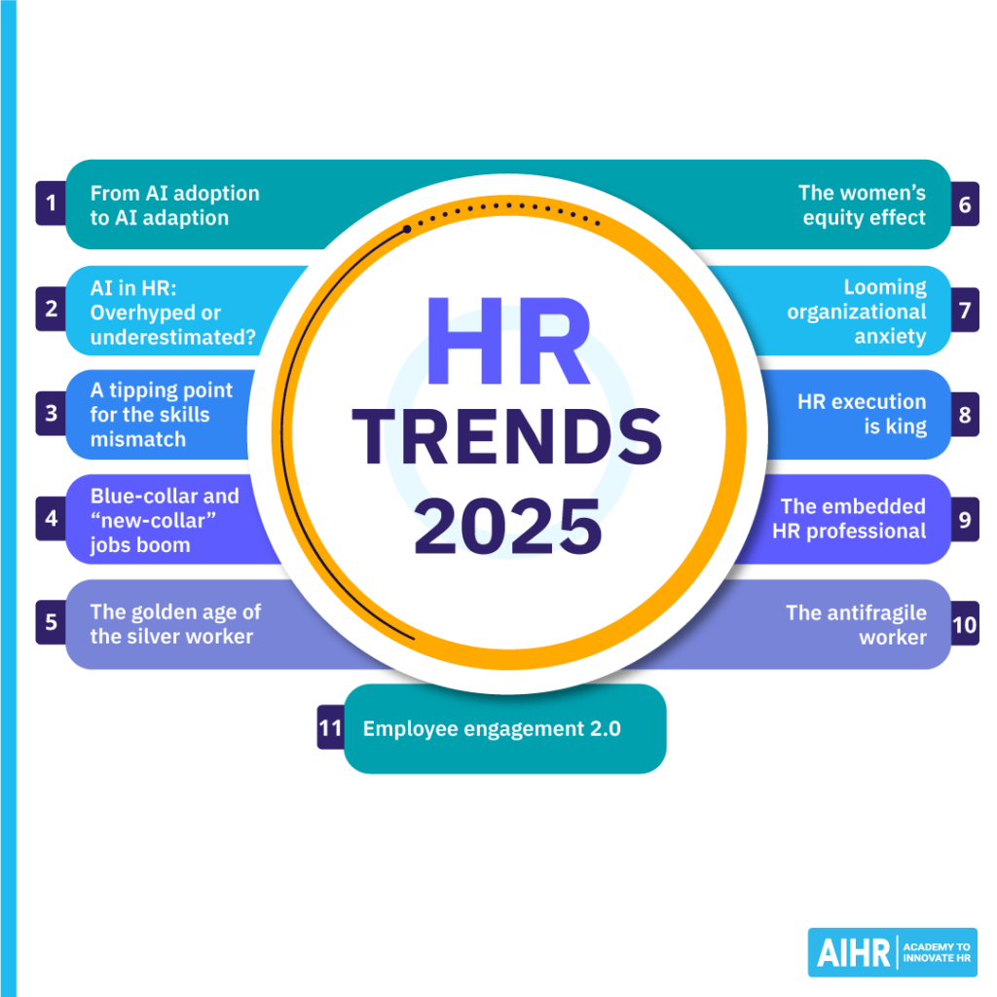A Human Resources Information System (HRIS) for RSIP will help the HR department in all aspects. Routine tasks like payroll processing and record keeping can be automated so that HR employees can focus on higher priority tasks. Even allowing employees to do electronic signatures for documents instead of doing it on paper will save time. Data management will become better to support strategic planning and supporting the company’s future goals.

Figure 3: HR Trends 2025

With all this data in hand, using an HRIS system can provide opportunities to implement AI into HR processes. According to the points in Figure 3, AI adaption is a trend in 2025 and that is not slowing down. HR departments can use AI to assist with employee onboarding, which can save time and allow employees to start working quicker. The workforce is constantly changing and the adoption of an HRIS system will prove to be beneficial in the long term. Systems like this can be changed and altered in whichever ways that maximizes the potential of how processes are in the HR department.

## Information Technology (IT)

### Situation

At RSIP, the IT infrastructure is outdated and is lacking in many areas. The company doesn’t have a set IT system, there are flaws all around. Without the necessary IT setup, there is a lack of flexibility and security. If the company plans on implementing various software, upgrades are needed for RSIP to handle the increased workload in the expansion.

### Analysis

|  |  |
| --- | --- |
| Data/Information Use Case | |
| Function Name: Information Technology (IT) | |
| Process Name | Notes/Comments |
| Device & Hardware | Most employees are using legacy desktop systems with no modern software. This causes slow performance. |
| Communication | Old landline phones are being used as the main communication device. This is not reliable. |
| Cybersecurity | Only basic antivirus software is used. This puts the company, employee, and customer’s data in jeopardy. |
| Remote Access | Unreliable VPNs and poor cloud access management tools. |
| Support | No tools for user support or monitoring. Technological issues become harder to solve. |

RSIP’s current IT environment is lacking many key features, which will heavily affect the company’s operations. As the company expands and more softwares are implemented, there will be more technical problems. Without a proper system in place, these issues will take forever to monitor and troubleshoot. Technology improvements are needed.

### Solution

To improve RSIP’s IT infrastructure, system performances need to be improved. Secure remote accesses and communication to the IT department is needed. By upgrading and addressing these problems, RSIP will be prepared to take on digital systems while assisting workers in-person or remote. This will help with solving issues across multiple locations as well because other buildings may have similar problems that were addressed in another location.

|  |  |  |
| --- | --- | --- |
| Requirement Specification | | |
| Technology Name | IT Infrastructure & Support | |
| Requirement Name | ID# | Description/Definition |
| Modern Hardware | IT-001 | Outdated hardware should be replaced and updated. |
| Communication System & Support | IT-002 | Ticketing and conferencing tools. |
| Cybersecurity | IT-003 | Install various security tools on network and devices. |
| Remote Access | IT-004 | Install reliable VPNs for remote employees. |
| Network Infrastructure | IT-005 | Upgrade systems to support the expansion. |

### Importance of an IT Infrastructure | by APS Progressive Solutions | MediumBenefit

Figure 4: IT Infrastructure Services

Upgrading RSIP’s IT infrastructure creates endless benefits that align perfectly with the company’s goals. With the current system, the data of the company is at risk. As shown in Figure 4, the IT infrastructure is made up of 5 main components. By investing in the components, RSIP will position itself to operate more securely. In today’s world, it is important to protect data. Hackers and scammers are constantly trying to steal confidential information, especially for companies. With a strong IT infrastructure, all data is safe, and the organization will be prepared for any technical challenges that may arise.

## Executives

### Situation

RSIP’s executives play a key role in the company’s planning, especially during the expansion. Executives rely on manual reporting, emailing, and in-person meetings to give updates. This approach is slow and a more centralized system for communication is needed to allow executives to share information easier and to contact each other under one platform.

### Analysis

The executive team at RSIP is expecting higher amounts of pressure and decision-making because of the expansion. They will be looking at making decisions across multiple locations and departments, so having a modern communication tool is key. This team needs to be agile and responsive to make sure everything is in check during the transition.

### Solution

|  |  |  |
| --- | --- | --- |
| Requirement Specification | | |
| Technology Name | Communication & Collaboration Platform | |
| Requirement Name | ID# | Description/Definition |
| Cloud-Based Documentation | E-001 | Real-time editing and sharing for documents. |
| Communication | E-002 | Messaging, video calls/meetings, scheduling and file sharing. |
| Mobile Device Compatibility | E-003 | Team members can collaborate and communicate on various devices on the go with full functionalities. |

### Benefit

Implementing a platform like this can help the executive team consistently communicate with each other and reduce any miscommunication. No matter where they are, having this platform will help them stay connected and be updated regularly. Usually, executives are always on the move or working remotely, so having the flexibility to work remotely allows them to be more productive while keeping up with all the work.

# Technology

Technology is the main point in digital transformation being the foundation for improving the overall efficiency, communication, and data centralization for RSIP. Having the right systems in place is important for RSIP’s expansion plans to ensure long-term success. With a CRM, IMS, HRIS, ticketing system, and a communication platform, all these systems will contribute profitable revenue growth.

## Software

For RSIP’s digital transformation, choosing the correct softwares is vital to the company’s success. Each department will need technology that can help them collaborate with each other. Softwares offer a range of features, but they sometimes don’t address everything. It is important that the software chosen for each system can solve the current business problems and can be upgraded in the future.

|  |  |  |  |  |
| --- | --- | --- | --- | --- |
| Technology Solution Options Comparisons | | | | |
| Technology Name | Customer Relationship Management (CRM) | | | |
| Requirement Name | ID# | Zoho CRM | Salesforce | HubSpot |
| Track & Manage Customer Data | C-001 | Y | Y | Y |
| Track & Report Sales | C-002 | Y | Y | Y |
| Process Orders | C-003 | Y | Y | N |
| Generate Quotes | C-004 | Y | Y | Y |
| Mobile Access | C-005 | Y | Y | Y |
| Sync with Inventory Management System | C-006 | Y | Y | Y |
| Route Optimization | C-007 | Y | Y | N |
| AI Sales Insights | C-008 | Y | Y | Y |

These three CRM systems offer good features that align with what RSIP needs, but the two that stand out are Salesforce and Zoho. Both Salesforce and Zoho’s CRM systems satisfy the requirements requested while also offering AI assistants. HubSpot fulfills some requirements but is limited and lacks the process orders feature. Salesforce and Zoho’s CRM systems are good options, but Zoho is the one that stands out the most. Zoho’s enterprise CRM is much cheaper than Salesforce’s enterprise CRM. Also, RSIP is looking to have an IMS system be implemented. Zoho offers their own IMS system, while Salesforce doesn’t. Having both the CRM and IMS system under one platform would centralize the information and data, making it easier to navigate for the employees.

|  |  |  |  |  |
| --- | --- | --- | --- | --- |
| Technology Solution Options Comparisons | | | | |
| Technology Name | Inventory Management System (IMS) | | | |
| Requirement Name | ID# | Zoho Inventory | NetSuite | Sortly |
| Tracking Stock Levels | I-001 | Y | Y | Y |
| Automate Stock Updates | I-002 | Y | Y | Y |
| Centralized Inventory | I-003 | Y | Y | Y |
| System Integration Across Other Departments | I-004 | Y | Y | N |
| Access Controls | I-005 | Y | Y | N |
| Barcode Scanning | I-006 | Y | Y | Y |

Three possible IMS solutions can be Zoho, NetSuite, or Sortly. Zoho and NetSuite addresses all the requirements mentioned, while Sortly has some limitations regarding syncing information across other departments and access controls. As mentioned before, Zoho offers both the CRM and IMS systems, so Zoho would be best since it is better to have two systems under one platform.

For the Finance & Accounting department, they are using QuickBooks Desktop, which creates an easy path for an upgrade. QuickBooks Online Advanced offers a familiar interface that makes it easy for current employees, but now it has more modern features and tools for the increased workload. This upgrade also reduces delays and disruptions since the foundation of the system is already in place.

|  |  |  |  |  |
| --- | --- | --- | --- | --- |
| Technology Solution Options Comparisons | | | | |
| Technology Name | Human Resources Information System (HRIS) | | | |
| Requirement Name | ID# | ADP | Zoho People | Gusto |
| Centralized Employee Database | H-001 | Y | Y | Y |
| Automated Onboarding & Payroll | H-002 | Y | Y | Y |
| Employee Tracking | H-003 | Y | Y | Y |
| Employee Self-Service | H-004 | Y | Y | Y |
| Reporting | H-005 | Y | Y | Y |

These HRIS platforms are great options that go along with the requirements for RSIP. Each of them addresses all the needs. Since all softwares fulfill what RSIP needs, the one that would be best to use is Zoho People. With the CRM and IMS being under Zoho, it would be great to have another software under it as well. Having three systems with Zoho will make it easier to contact the service for support since everything is in one place. User accounts would be under the same platform as well, so employees won’t need to create multiple accounts on different softwares.

|  |  |  |  |  |
| --- | --- | --- | --- | --- |
| Technology Solution Options Comparisons | | | | |
| Technology Name | IT Support | | | |
| Requirement Name | ID# | Zoho Desk | Freshdesk | ServiceNow |
| Communication System & Support | IT-002 | Y | Y | Y |

All these IT support options are great and do what they need to do, but there is a name here that has been seen with the other systems. That is Zoho. They offer a ticketing system that is cheaper than the other options and it is under the same platform as the other chosen systems. At this point, having Zoho Desk is the best option because all other systems are on it as well.

Microsoft 365 will be implemented for RSIP’s executive team and employees. The platform is used by most companies in the industry and provides various tools ranging from conferencing to file sharing. Everyone will be able to collaborate in real time and securely store their files with the cloud storage. All departments will use this and be able to communicate with one another seamlessly.

All laptops and desktops will be running on Windows 11.

## Hardware

* Desktops (Warehouse Staff, Inside Sales Staff):
  + Type: Lenovo ThinkStation P3 Ultra Small Form Factor Workstation
  + Year 1: 6 desktops
  + Year 2: 8 desktops
  + Year 3: 12 desktops
  + Given to those at fixed desks.
* Laptops (Office-Based Staff):
  + Type: Lenovo Yoga 9i 2-in-1 Intel (14")
  + Year 1: 24 laptops
  + Year 2: 37 laptops
  + Year 3: 50 laptops
* Smartphones (Field Sales, Executives):
  + Type: Samsung S24 128GB
  + Year 1: 6 smartphones
  + Year 2: 8 smartphones
  + Year 3: 12 smartphones
* Tablets (Optional for Field Sales or Warehouse Staff):
  + Type: Lenovo Yoga 9i 2-in-1 Intel (14")
  + Year 1: 24 laptops/tablets
  + Year 2: 37 laptops/tablets
  + Year 3: 50 laptops/tablets
  + Can be used as a tablet or laptop.
* Hotspots (Sales Representatives, Executives):
  + Type: Verizon TCL LinkZone 5G UW
  + Year 1-3: 6 hotspots

## Data

As new systems are implemented for RSIP, all departments need to understand how the data works. The new CRM system will hold customer information and sales activities. The IMS system will track inventory and product data. The upgraded QuickBooks will hold all financial data of the company. All employee information will be held in the HRIS system. RSIP’s communication information will be secured in Microsoft 365. With the CRM, IMS, HRIS, and support systems all being under one platform, real-time data will be easily shared between departments. There will be data governance policies in place to protect the data and all of this will contribute to the company’s long-term success towards profitable revenue growth.

## Infrastructure

The infrastructure diagram in Figure 5 shows the IT and networking setup. It also shows how users can access the systems both in office and remotely. The systems being implemented are primarily cloud systems, so devices are able to connect to them anywhere as long as there is an internet connection.

Figure 5: Infrastructure Diagram

# People

RSIP’s team is made up of experienced professionals that have been with the company for quite some time. They are confident in their craft and each person has a dedicated system of handling their work. Even though they are experts in their own ways, digital transformation may not be too friendly to them. The employees are used to their manual processes, so any change may interrupt their routine work. It is important to provide them with proper training, support, and encouragement during this transition process. Being able to do so will ensure a smooth transition and have the workers realize how much good the change is doing in helping them with their work.

# Structure

No structure changes anticipated.

# Most Difficult Technical Task

The most difficult technical task RSIP will face during this transition is being able to transfer the existing data over to the new systems without corrupting it. With there being many manual processes across all departments, it may be tough to bring the data over. There also may be an extended amount of downtime, which could delay the expansion.

## Analysis

The data currently is held in different places including Excel sheets, email inboxes, and even written down on paper. With this type of organization, employees might not be confident in the timeline of these documents. For the new systems to work correctly, data must be inputted as best and accurately as possible to get the best results.

## Solution

Firstly, all current data must be organized by department and by user. All users and departments will then collaborate to clean up and confirm that their data is good to go to be migrated. It is also important to keep a backup of this data, just in case something gets lost in the process. The new systems offer various importing tools with migration support. Being able to take advantage of those features can help make the transition much easier. Before doing the actual migration, it is best to test with sample data first. If there are issues during that process, it would be easier to troubleshoot from there and it would be less pressure on the IT department. Once the data is transferred, departments and users need to confirm that everything is there. All of this must be done during a period that isn’t busy. This will give the IT department time and cause users less disruptions.

# Risks & Mitigation

Digital transformation requires various processes that can significantly impact business operations and affect the current workplace culture. 80% of IT’s initiatives do not reach their fullest potential due to poor planning and unexpected challenges that come up along the way. Being able to identify and predict these risks before they occur can ensure the long-term success for the company.

## Risk 1 – Employees Resistance to Change

## Since RSIP’s employees have worked there for a prolonged period, each person has most likely developed a routine to do their everyday work. They are used to their ways, which makes it seem like their current processes have no problems. Introducing new technological systems will make working more efficient, but it won’t seem like it to everyone in the company. It would serve more as a disruption, which leads to conflict and resistance to change.

Risk Mitigation: A change management strategy is crucial in this given situation. Being able to communicate and train all employees will lessen the chance of frustrations flaring out within the organization. Training will include hands-on walkthroughs along with different workshops to simulate everyday tasks depending on the department. During these sessions, it is important to communicate the benefits of the new system and make sure everyone is on the same page for the transition.

## Risk 2 – Lack of Experience

## Being the lone IT person, there may be problems when coming across technological issues. As digital transformation is being implemented, there will be demand for IT support in all departments. The lack of technical knowledge will also contribute to the challenges because it can lead to inefficient troubleshooting and dependencies on outside technical support.

Risk Mitigation: Professional development and training for current workers will be essential in lessening the load on the IT department. Training can be done through various mandatory training programs. Systems that are implemented need to have reliable technical support to easily resolve issues that come up.

## Risk 3 – Security Concerns

## RSIP lacked technology in all aspects and that creates security concerns when trying to enforce digital transformation. During the transition, RSIP is prone to attacks and unauthorized access from hackers because without a cybersecurity infrastructure in place before the transition, everything here is brand new. Data will not be protected 100% and any loss of this information will result in financial loss and damage to the company’s reputation.

Risk Mitigation: Making sure there are strong cybersecurity measures in place during the transition is key to protecting the company’s data. This includes implementing strong firewalls, VPNs, and making sure employees receive proper cybersecurity training. Also, data should have different security measures depending on how sensitive it is. More confidential information should be limited to specific personnel with strict access controls.

# Timeline

|  |  |  |
| --- | --- | --- |
| **RSIP Digital Transformation Project Timeline** | | |
| **Phase** | **Time** | **Activities** |
| Phase 1: Planning and Preparation | 4 Weeks (Weeks 1-4) | Finalize Softwares |
| Phase 2: Data Cleanup | 4 Weeks (Weeks 5-8) | Review all data across departments and verify |
| Phase 3: Set up Infrastructure | 2 Weeks (Weeks 9-10) | Upgrade and test all hardware/network |
| Phase 4: Install Software Systems | 8 Weeks (Weeks 11-18) | CRM, IMS, HRIS, QuickBooks Online, Ticketing System |
| Phase 5: Data Migration | 3 Weeks (Weeks 19-21) | Transfer all data over to new systems |
| Phase 6: Testing & Training | 3 Weeks (Weeks 22-24) | Test all systems and train users |
| Phase 7: System Rollout | 1 Week (Week 25) | All systems a go |
| Phase 8: Support & Troubleshooting | Ongoing | Support users where needed and troubleshoot any problems that come up |

# Budget

|  |  |  |  |  |
| --- | --- | --- | --- | --- |
| **Three Year Implementation Budget Summary** | | | | |
| **Line Item** | **Year 1** | **Year 2** | **Year 3** | **Total** |
| Software | $35,000 | $40,000 | $42,000 | $117,000 |
| Hardware | $52,500 | $78,100 | $107,200 | $237,800 |
| Data | $10,000 | $5,000 | $3,000 | $18,000 |
| Infrastructure | $15,000 | $5,000 | $5,000 | $25,000 |
| Other | $10,000 | $8,000 | $7,000 | $25,000 |
| **Total** | $122,500 | $136,100 | $164,200 | $422,800 |

# Conclusion

Digital transformation for RSIP is not just about the technology upgrades, but it is a strategic plan that helps the company move towards profitable revenue growth. As the company expands into new regions, the size increases, making current processes difficult to use. By being able to implement cloud-based solutions like CRM, IMS, HRIS, QuickBooks Online, and a ticketing system, operations will become much smoother.

Even though there are many risks, the end goal makes the risks worthwhile. Being careful with the current data and cleaning it up effectively will ensure a good transition to the new systems. Businesses around the world are adopting these systems and it is a crucial element to stay relevant. RSIP is prepared for this technological upgrade and ready for their next stage in growing the organization.

# Appendix

## Infrastructure Diagram

### HQ and Warehouse

### Remote Offices

### Salespeople on the Road

# Endnotes

## General

“Ai CRM.” HubSpot. Accessed March 28, 2025. <https://www.hubspot.com/products/crm/ai-crm?hubs_content=www.hubspot.com%2Fproducts%2Fcrm&hubs_content-cta=freecrm-middle-salesleader>.

Chatgpt. Accessed March 29, 2025. https://chatgpt.com/.

“Cloud Based HR Software Solution: HRMS: Zoho People.” Zoho. Accessed March 28, 2025. <https://www.zoho.com/people/index1.html>.

“Features.” Sortly, March 25, 2025. <https://www.sortly.com/features/>.

“Free Inventory Management Software: Zoho Inventory.” Free inventory management software | Zoho Inventory. Accessed March 28, 2025. <https://www.zoho.com/us/inventory/free-inventory-management-software/>.

“Freshdesk Ticketing System.” Freshworks. Accessed March 28, 2025. <https://www.freshworks.com/freshdesk/ticketing/>.

Gusto: Online Payroll & HR Solutions | #1 in Satisfaction Score. Accessed March 29, 2025. <https://gusto.com>.

“Hris Software & Solutions.” ADP. Accessed March 28, 2025. <https://www.adp.com/what-we-offer/hr-information-systems.aspx>.

“It Service Management (ITSM) Overview: Solution Brief.” ServiceNow. Accessed March 28, 2025. <https://www.servicenow.com/standard/resource-center/solution-brief/sb-itsm.html>.

“Microsoft 365 for Business: Small Business: Microsoft 365.” Microsoft 365 for Business | Small Business | Microsoft 365. Accessed March 28, 2025. <https://www.microsoft.com/en-us/microsoft-365/business>.

“Mobile Hotspot Devices for Business: 5G and Mobile Hotspots: Verizon Business.” Mobile Hotspot Devices for Business | 5G and Mobile Hotspots | Verizon Business. Accessed March 28, 2025. <https://www.verizon.com/business/shop/products/devices/mobile-hotspots>.

NetSuite.com. “What Is Netsuite Inventory Management?” Oracle NetSuite. Accessed March 28, 2025. <https://www.netsuite.com/portal/products/erp/warehouse-fulfillment/inventory-management.shtml>.

“Professional Services Accounting Software.” QuickBooks. Accessed March 28, 2025. <https://quickbooks.intuit.com/online/advanced/industries/professional-services/>.

“Salesforce CRM: Try the World’s #1 AI CRM.” Salesforce. Accessed March 28, 2025. https://www.salesforce.com/crm/.

Singh, Saurabh. “10 Reasons Your Business Needs an Inventory Management Software.” Appinventiv, April 19, 2024. https://appinventiv.com/blog/benefits-of-inventory-management-software/.

“The 11 Greatest Benefits of CRM Platforms.” Salesforce. Accessed March 28, 2025. https://www.salesforce.com/crm/benefits-of-crm/.

Vulpen, Erik van. “11 HR Trends for 2025: Embracing Disruption.” AIHR, February 18, 2025. https://www.aihr.com/blog/hr-trends/.

Writer, Jade Artry. “CRM Benefits 2025: Can the Software Help Your Business?” Tech.co, March 4, 2025. https://tech.co/crm-software/benefits-of-crm.

“Zoho CRM: Top-Rated Sales CRM Software by Customers.” Zoho. Accessed March 28, 2025. <https://www.zoho.com/crm/>.

“Zoho Desk vs. Freshdesk: Compare and Make the Right Choice.” Zoho. Accessed March 28, 2025. <https://www.zoho.com/desk/lp/freshdesk-alternative.html?network=g&device=c&keyword=freshdesk+ticketing+system&campaignid=21151430101&adgroup=166124744608&matchtype=e&placement=&adid=695303750581&gad_source=1&gclid=Cj0KCQjwkZm_BhDrARIsAAEbX1G4TSkv1Ar6Z7W2Kv3VrKbf9XonHtZHXox4rqANz8HiKSB7djGN0b4aAo1WEALw_wcB>.

## Budget

“Buy Galaxy S24 Unlocked 256GB Smartphone.” Samsung US. Accessed March 28, 2025. <https://www.samsung.com/us/smartphones/galaxy-s24/buy/galaxy-s24-128gb-unlocked-sm-s921ulbaxaa/>.

“Lenovo ThinkStation P3 Ultra SFF Workstation: Redefining the Power of Small.” Lenovo ThinkStation P3 Ultra SFF Workstation | Redefining the power of small | Lenovo US. Accessed March 28, 2025. <https://www.lenovo.com/us/en/p/workstations/thinkstation-p-series/thinkstation-p3-ultra-workstation-sff/len102s0014?orgRef=https%253A%252F%252Fwww.pcmag.com%252Fpicks%252Fthe-best-business-desktops&clickid=STTS%3AqVapxyKRf%3A1dA2z-wwsUks3fGTNRXHix40&irgwc=1&PID=10915&acid=ww%3Aaffiliate%3Abv0as6&cid=us%3Aaffiliate%3Acxsaam>.

“Lenovo Yoga 9i 2-in-1 (14″ Intel): Ai Boosted 2-in-1 Laptop for Creatives: 83AC0002US.” Your One-Stop Shop for Laptops, PCs, Tablets & More. Accessed March 28, 2025. <https://www.lenovo.com/us/en/p/laptops/yoga/yoga-2-in-1-series/lenovo-yoga-9i-2-in-1-gen-9-14-inch-intel/83ac0002us?cid=us%3Asem%7Cse%7Cgoogle%7Cshoppping_desktop_push%7Cgs_notebooks%7C%7C83AC0002US%7C1341262706%7C56667337114%7Cpla-2405928264411%7Cshopping%7Cmix&gad_source=1&gclid=Cj0KCQjwkZm_BhDrARIsAAEbX1EBoOWEA_7TdfDkbvhiVsSmRxUDj9n0Axfny_KmSxPjmei9QXE2nf0aAuT7EALw_wcB>.