  - 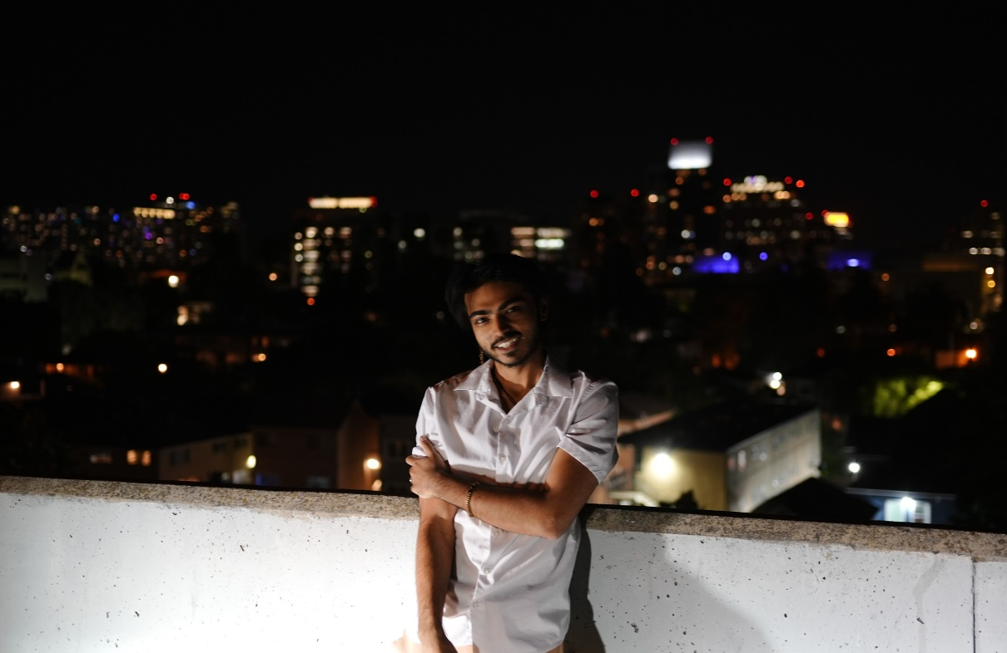

Neel Lal

Professional Summary
Dedicated and versatile professional with diverse experience ranging from teaching and retail to project coordination. Demonstrated ability to handle challenging situations with patience and creativity. Skilled in problem-solving, communication, and team collaboration. Currently pursuing a degree in Business Administration with a focus on Management Information Systems, combined with practical experience in Java, Python, and Excel. Seeking to leverage my skills and experiences in a dynamic and challenging role.
- Contact  Neel Lal  neellal1709@gmail.com  510-796-6007  https://www.linkedin.com/in/neel-lal/  - Education  San jose State University  Business Administration, Management Information Systems  Minor: Computer Science  Relevant Coursework:  Data Structures and Algorithms, Financial Accounting, Legal Environment of Business, Software Engineering, Discrete Math  Estimated Graduation: June, 2025  - Skills  Java, Python, Excel, ChatGPT  Analytical Thinking, Creative Problem Solving, Effective Communication, Patience  References  Available upon request.  Interests:  Chess, Guitar, Exploring, Programming, Rock Climbing, Skating, Learning, Mindfulness, Hiking |  | Experience  Piano teacher, Self employed  Bay Area, CA | 2020-Present  - Fostered a love of music in children through personalized piano instruction.  - Developed marketing and communication strategies to expand client base.  - Tailored teaching methods to individual learning styles, enhancing student engagement and progress.  Project Coordinator, Reliable liquidation  San Leandro, CA | Jan 2022 – December 2022 |  - Coordinated furniture placement and logistics for hotel liquidation projects.  - Created detailed spreadsheets and layouts, improving operational efficiency.  - Navigated unforeseen challenges, showcasing adaptability and problem-solving skills.  Store associate, ups store  Newark, CA | June 2021 – January 2022 |  - Provided customer service in shipping, printing, and mailbox services.  - Managed challenging customer interactions with patience and professionalism.  - Cultivated a network of professional contacts through daily customer interactions.  Tutor, eye level learning center  Union City, CA | August 2019 – March 2020 |  - Delivered Math and English instruction to diverse groups of students.  - Adapted teaching methods to meet individual student needs, enhancing learning outcomes.  - Developed strong problem-solving and patience skills in a dynamic educational environment.

